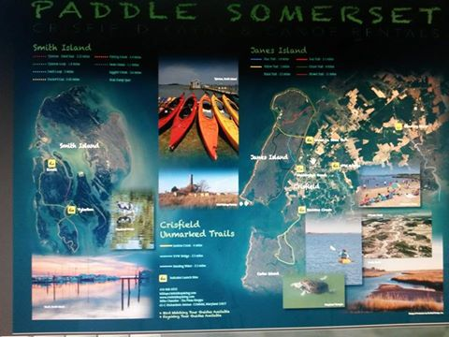 |  |  |  | Kayak Crisfield.com  Crisfield – MD
Smith Island Kayakers

- Allow yourself 1 hr arrival for the boat and my place. (Just like the airport.) You will need this time to fill out our info - Make Payment - Cash Only at my place - Unload your belongings at the dock- Find a parking spot and make payment to the captain & the parking spot.
- Bring an envelope to put your parking fee money in.
- Call us on the road to Crisfield around 9ish so we can get your boats to the ferry’s Captain before it gets too busy at Noon for the departure.
- Call me when you arrive in town, most times we can meet you at the dock to do paperwork so you can save some time instead of stopping at my place.
- The captain of the boat charges a small fee to transport the boats to the Island and to your B & B -- you must make those arrangements with the captain- All of his services are between you and him.
- Please while on the Island - Pull your boat far enough on the land - Tie the boat to a fixed object so the tide does not take it away while you are sleeping.
- Keep your jackets in the house- to keep them dry and so they do not blow away.
- Keep your paddles safety snuggled in the boat or if you have room in an indoor place.
- Any issues with the boat - let me know immediately so we can get you a new boat. We do not want you to have a bad experience while you are on vacation.
- When coming back over Please call me (443-783-2486) to remind me you are adventuring back into town, and we will need to pick up the boats from the dock. We do not want them blow off the dock or lose any equipment.
- The captain will place the equipment on the dock- and we will pick it up from there. Drive safely home.
- Remember you are visiting a dry Island (No alcohol) You may bring what you want, but they do not sell it on the Island. Also, groceries are limited so bring your goodies.

- Only B & B’s are on the Island, no hotels or evening dinning out places. Come prepared for food items.

- Remember to Shop Local. The residents on the Island main source of income are Tourist, Crabbing and Oysters.
65-C Richadson Ave
Crisfield- Md -21817
 |  | 443-783-2486
 |  | Billie968@gmail.com
 |  | www.kayakcrisfield.com

